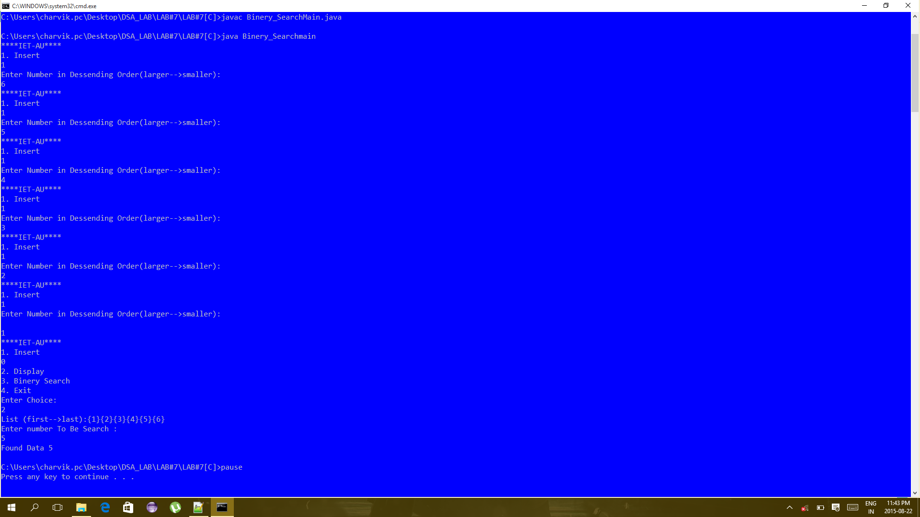

Here First of All I have Inserted An Number in Desending Order and After than I Display List {1,2,3,4,5,6} And After it I have Search An Element {5} and data found.

Figure Binery Search In Linear List

Here First of All I have Inserted An Number in Desending Order and After than I Display List {1,2,3,4,5,6} And After it I have Search An Element {20} and data not Found.

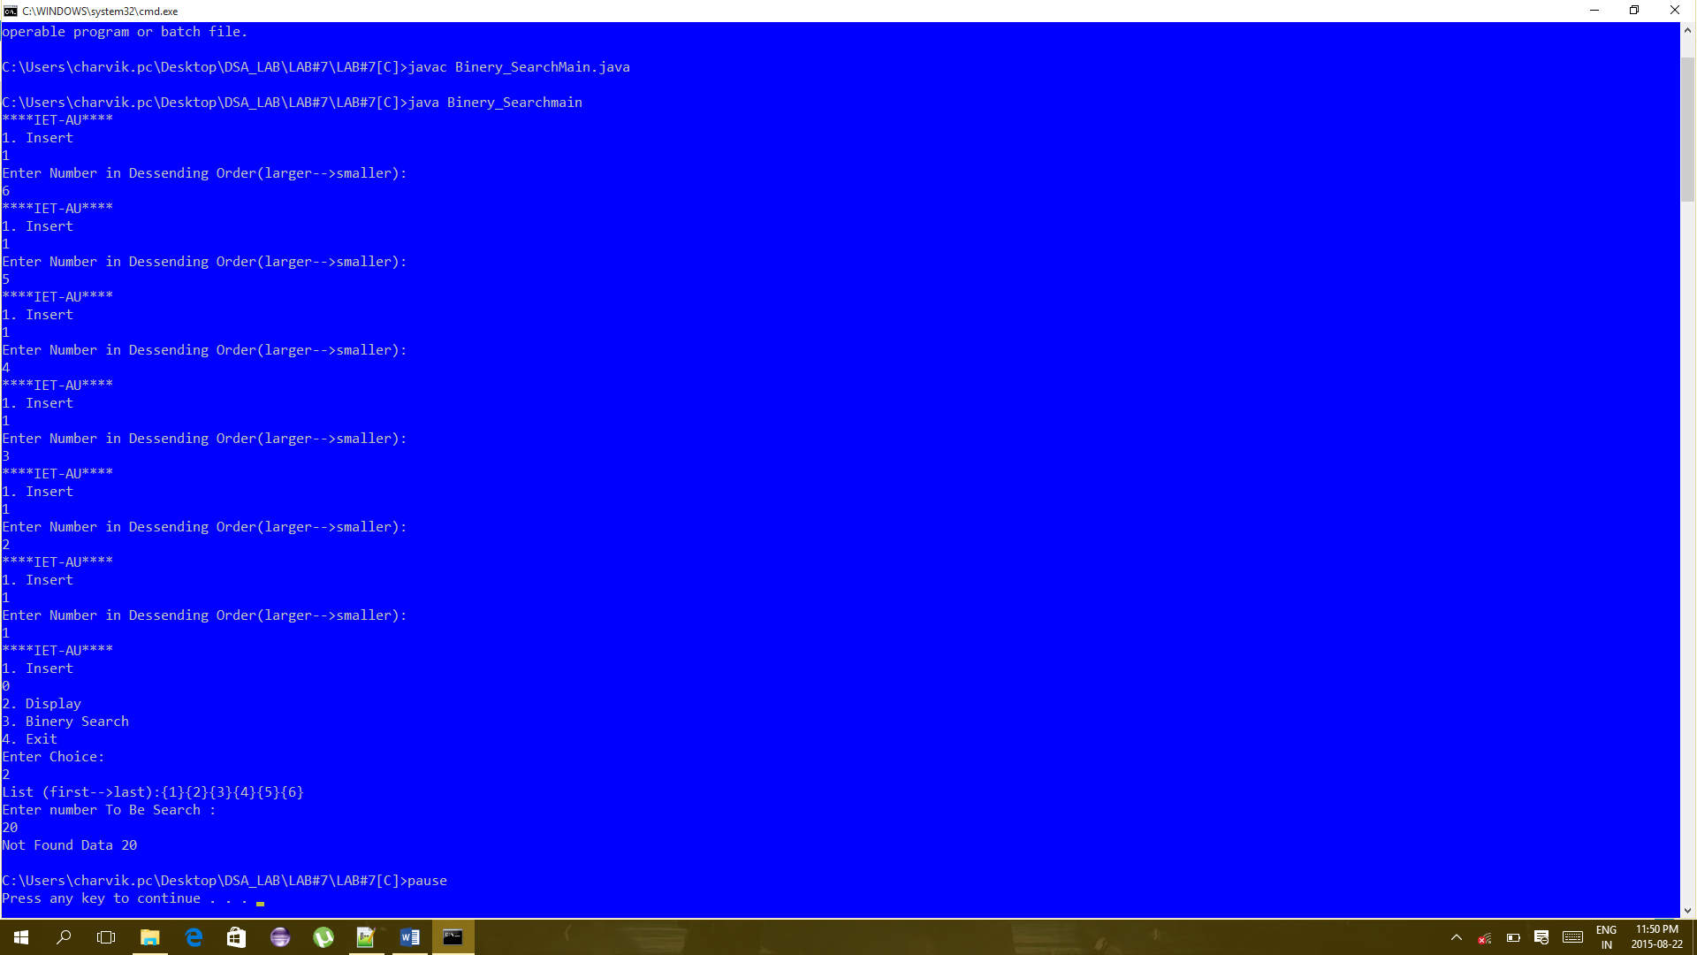

Figure Binery Search in Linear List

CODE SCREEN SHOT

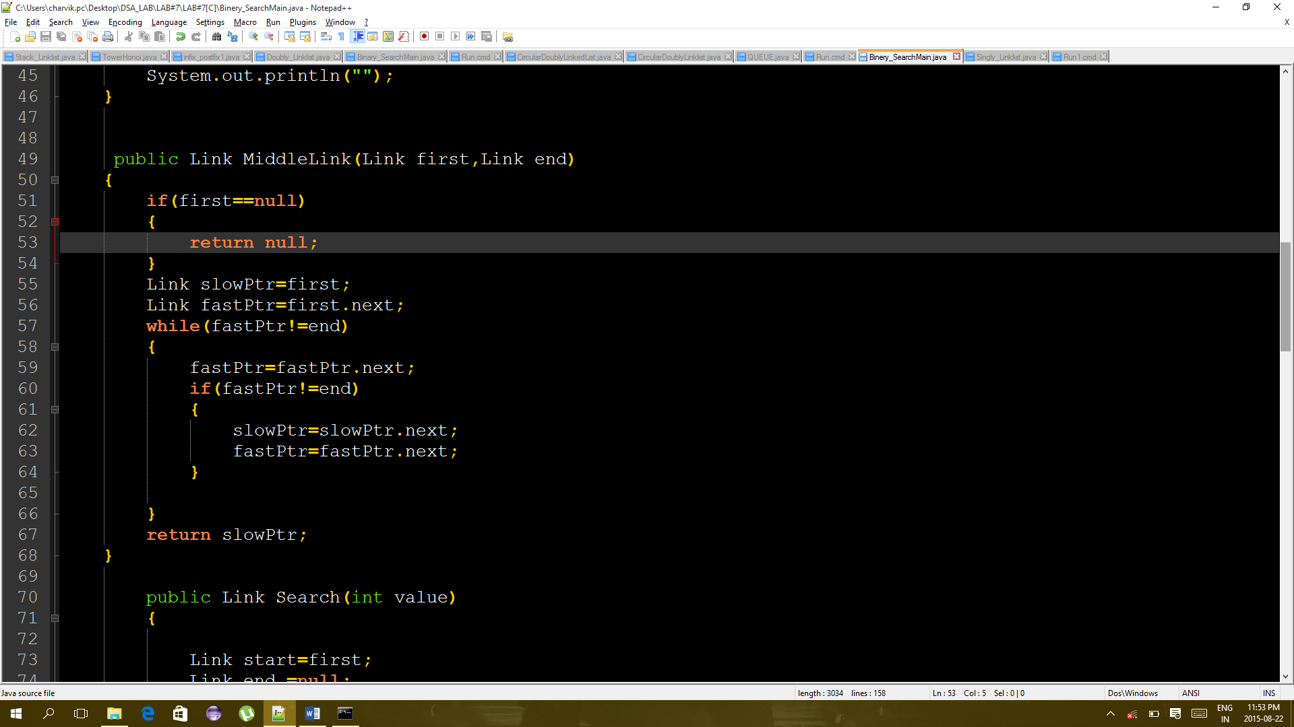

Figure CODE OF REACHING MIDDLE OF LIST

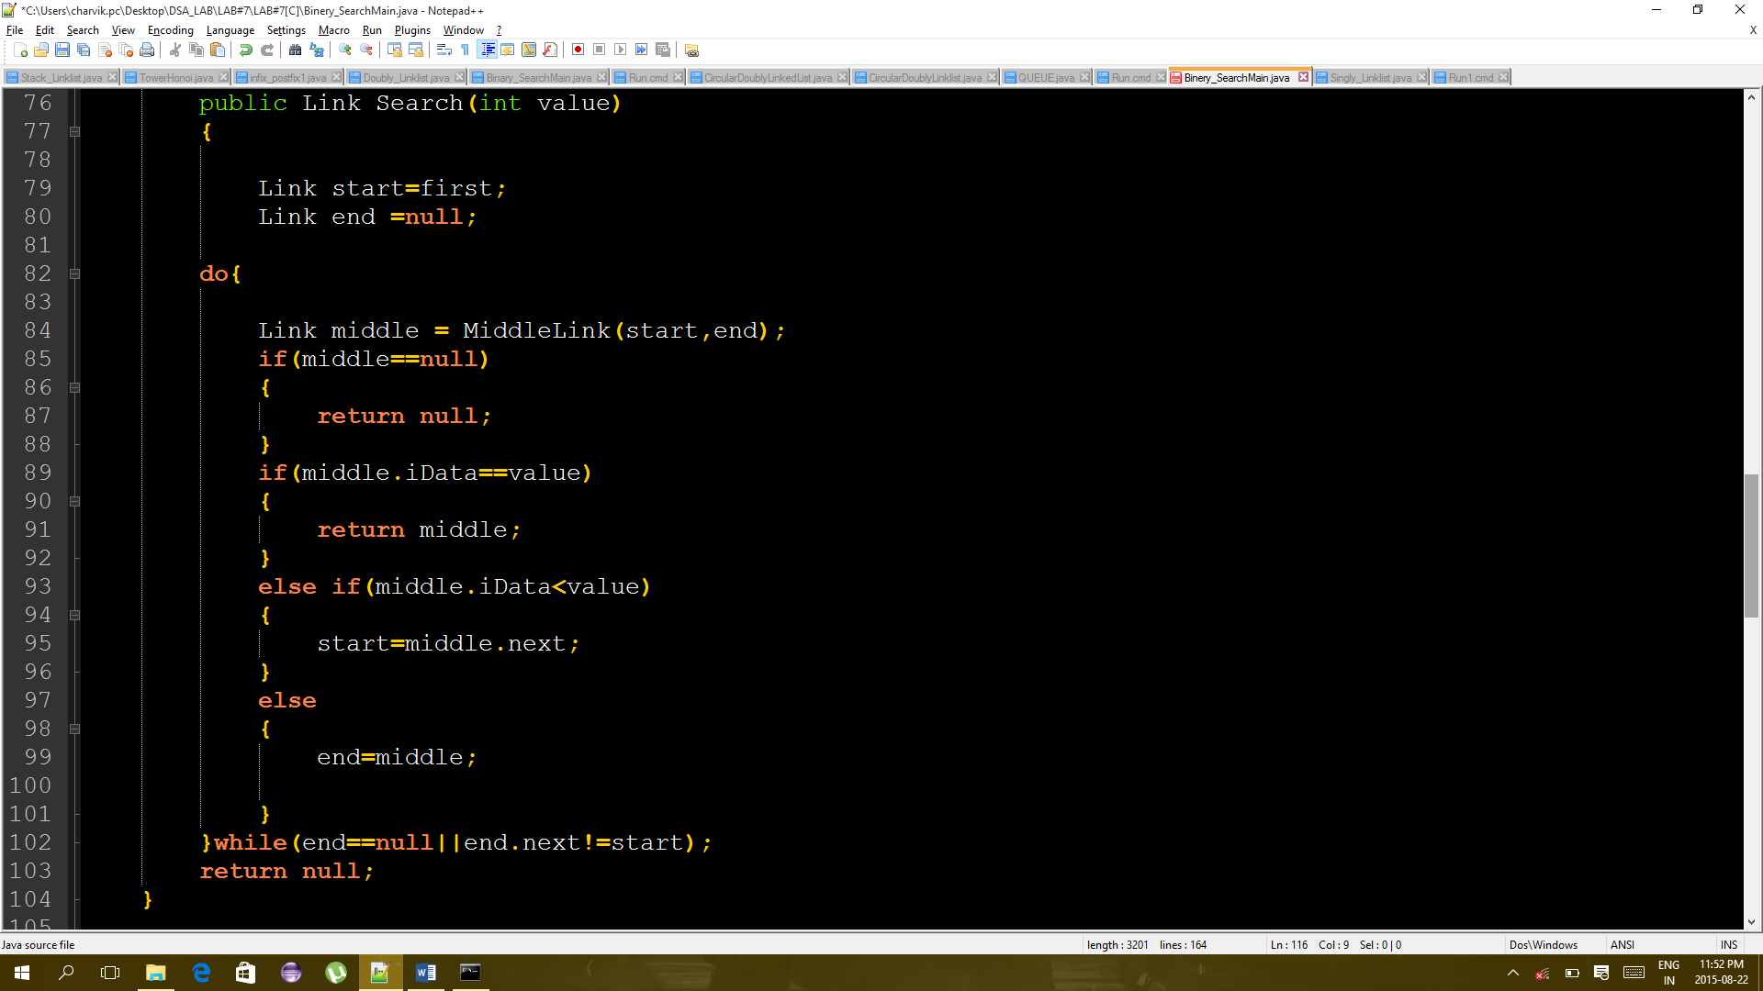

Figure 4 CODE OF BINERY SEARCH